**Airline Ticket Reservation System:**

**Problem Statement:**

Online airline ticketing saves time and money for the customer as well as the airline company thereby making air travel more customer-centric. This project is an attempt to simulate the basic concepts of an airline reservation system.

**A detailed description of the project:**

The airline ticket reservation system has the following features:

Customers can:

* Create an account
* Search for available flights for particular city-pair
* Book tickets for the class of your choice
* Cancel booked tickets
* View booked tickets history

Administrators can:

* Add/Modify flight schedules
* Viewing the booked ticket statistics

This system also incorporates a frequent flier miles points system for loyal customers providing additional benefits to them.

As the increase in population and huge increase on a day to day travel rates using flights increases. This brings about a need for an efficient system to cater the needs of the passengers thereby developing and establishing various database system aspects for the airline reservation which makes it economical and makes sure that all data and requirements are present in one space.

To be profitable in terms of turnover and profit generation Airlines must have an active and best reservation system.

As with the advent of the internet and the increased number of smartphone users, flight reservation system is used by many Airlines companies.

In today's world, online flight booking is emerging as a reliable quick and effective way to give your businesses a competitive edge. As a result, having a flight booking portal and a flight reservation system to run a successful travel business is becoming increasingly important for long-term success and better conversions for your business.

The flight reservation system is a web-based system that helps in centralizing flight data-flight schedules, seat availability, flight fares and booking for all Airlines with the help of global distribution system and provides real-time inventory and rates for clients and travel agents to book flight tickets online.

It involves airline schedules, fare Tariffs, passenger reservation and PNRs. As such the airline booking system assists passengers in booking flights by checking flight schedule, pricing/fares and seat availability.

A central reservation system, also called an airline or computer reservation system, serves as storagefor flight-related information like schedules, fares and rules for each booking class, passengername records (PNRs), e-tickets, etc. It's also involved in managing booking requests and ticket issuing.

The deregulation of commercial aviation rendered computerized reservation systems essential to airlines, and they remain so today.

Modern reservation systems allow passengers to directly make their bookings on their chosen airline's website. They store information like schedules, booking class rules, and fares/tariffs. The latter is particularly important today, in the age of dynamic pricing. Meanwhile, global distribution systems are the mid-point between travel agents and service providers.

**Software Requirements:**

OS: Windows 7 or higher

Language: PHP, HTML, CSS, MySQL

Database: MySQL database

Ide: Visual Studio, Sublime

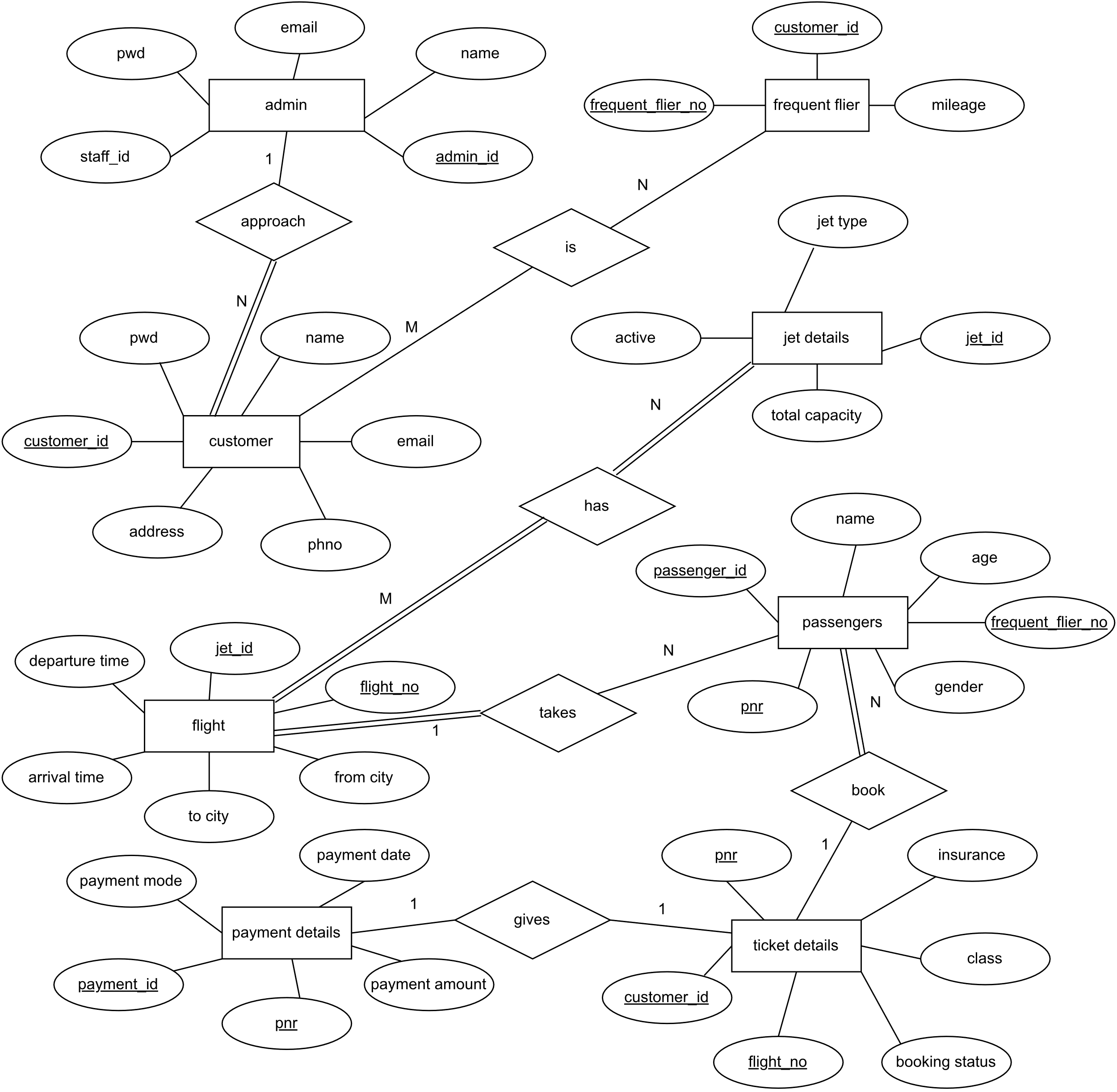

**ER Diagram**

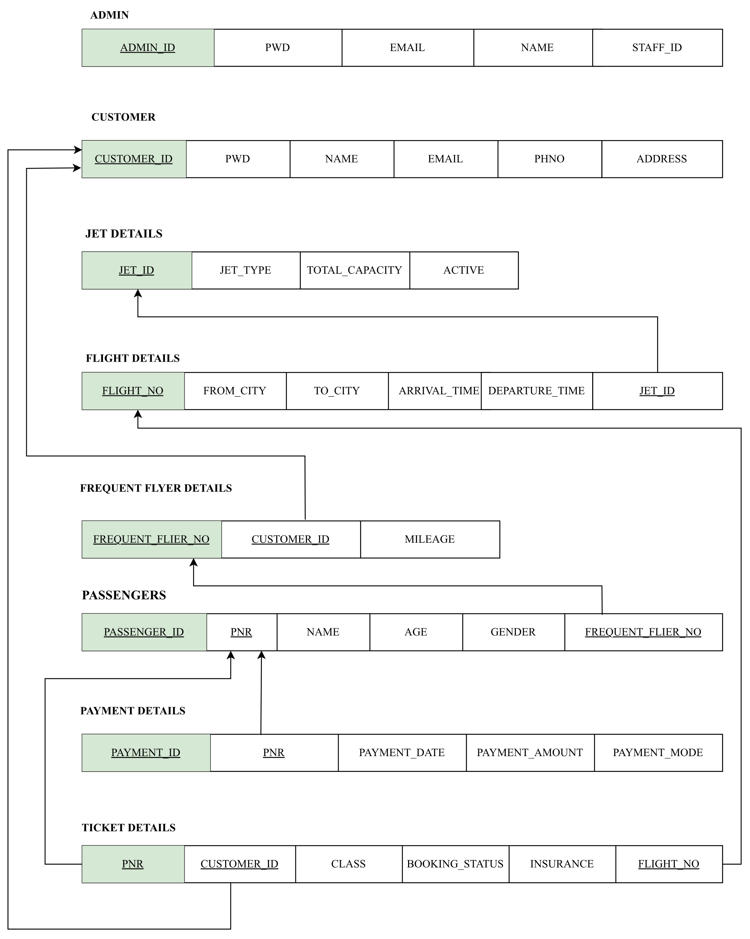

**Schema Diagram**